SIMATS ENGINEERING (SAVEETHA SCHOOL OF ENGINEERING)

Department of Computer Science and Engineering
ASSESSMENT TOOL 1 – Data Interpretation

Course Code: | ITA05 | Course Title: | Computer Vision
CO Assessed: | CO4 – Articulation (combining methods for evaluation) P4 | Assessment: | Assessment Tool 1 – Data Interpretation
Weightage: | 40% of CIA | Total Marks: | 100
CO4 Statement: | Compare object and pattern recognition techniques for interpreting visual data with spatial and motion characteristics. (BTL5)
Student Name: | Yavanika S | Reg. No.: | 192521258
Section / Batch: | ITA0512 | Date: | 17/08/2026

Code of Conduct
I Yavanika S [192521258] (Name / Reg No) certify that this submission is my original work and that I have adhered to the guidelines specified for this assessment. I understand that any violation of academic integrity rules will result in disciplinary action.
Signature of the Student: Yavanika S

Criteria | Weightage | Level 4 – Exemplary | Level 3 – Proficient | Level 2 – Developing | Level 1 – Beginning | Marks
Understanding of Data | 25% | Accurately interprets all data patterns, trends, and relationships | Interprets data correctly with minor gaps | Partial understanding; misses key trends | Misinterprets or fails to understand data
Analysis | 25% | Provides deep analysis with strong logical reasoning and justification | Provides reasonable analysis with some justification | Basic analysis with weak reasoning | No meaningful analysis provided
Application of Concepts | 20% | Effectively applies relevant concepts/tools to interpret data accurately | Applies concepts with minor errors | Limited application; requires guidance | Unable to apply concepts to data
Conclusion | 20% | Draws clear, meaningful conclusions with strong insights and implications | Provides valid conclusions with moderate insights | Conclusions are vague or weak | No clear or valid conclusions
Clarity | 10% | Presents interpretation clearly using proper structure, visuals, and terminology | Generally clear with minor issues | Lacks clarity or proper structure | Poor presentation and difficult to understand

Question 26: Feature Detection under Illumination Changes
Method | Normal Light | Low Light
A | 90% | 60%
B | 85% | 75%
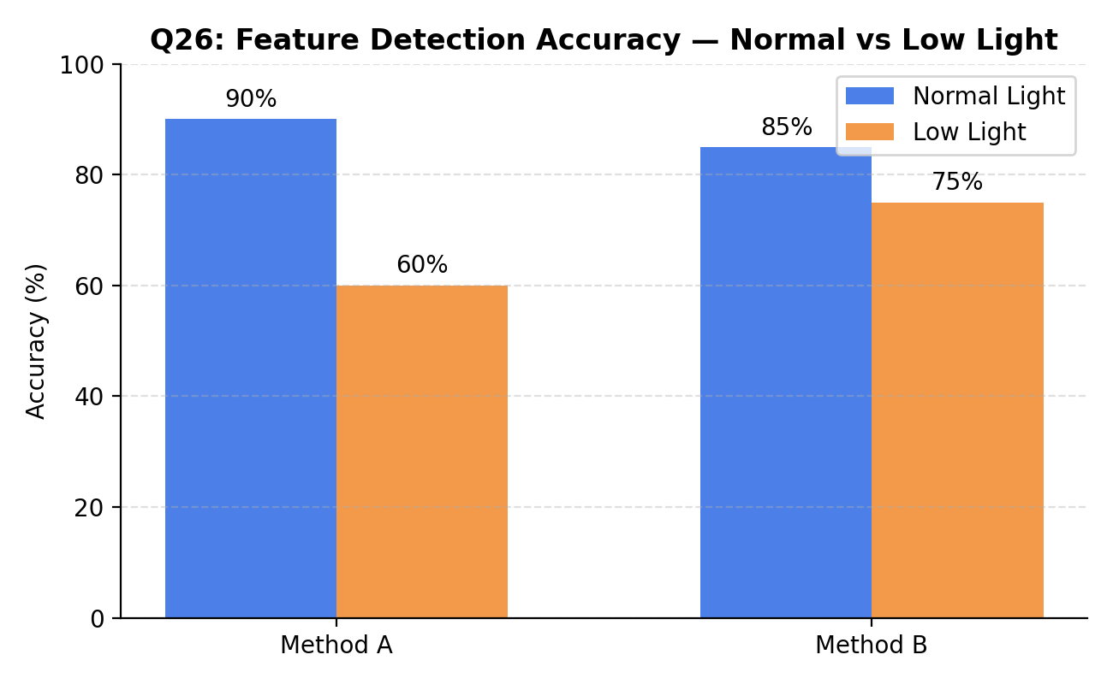

Understanding of Data
Method A achieves higher accuracy under normal lighting (90%) but drops sharply to 60% in low light, a fall of 30 percentage points. Method B starts slightly lower under normal conditions (85%) but retains 75% accuracy in low light, a much smaller drop of only 10 points.

Analysis
- Method A is optimized for well-lit, controlled conditions and relies heavily on strong gradient/edge information that degrades when illumination is poor.
- Method B likely uses illumination-invariant features (e.g., normalized gradients, histogram equalization, or adaptive thresholding), making it far more stable across lighting conditions.
- The performance gap (Δ = 30% for A vs Δ = 10% for B) is the key robustness indicator, not the peak accuracy alone.
Application of Concepts
Robustness in feature detection is judged by consistency across environmental variation, not just peak-condition accuracy. A small performance drop under adverse conditions indicates a more generalizable and reliable feature descriptor.
Conclusion
Method B is the more robust technique overall. Although Method A performs marginally better in ideal lighting, Method B's stability across normal and low-light conditions makes it the safer choice for real-world deployments such as outdoor surveillance, night-time driving assistance, or any environment with unpredictable lighting.

Question 27: Video Processing Pipeline Comparison
Pipeline | Accuracy | Speed
A | 88% | Fast
B | 92% | Moderate
C | 95% | Slow

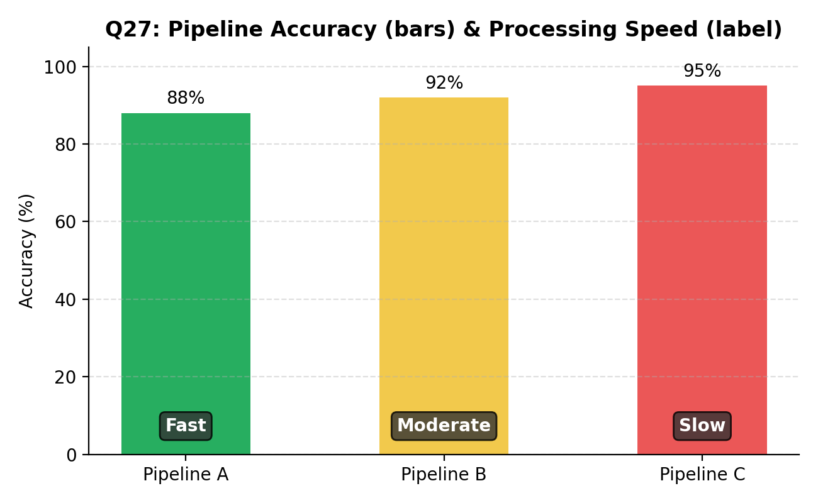

Understanding of Data
The three pipelines show a clear inverse relationship between accuracy and speed: Pipeline A is fastest but least accurate (88%), Pipeline C is most accurate (95%) but slowest, and Pipeline B sits in between on both dimensions (92%, Moderate speed).

Analysis
- Pipeline A likely uses lightweight models or frame skipping, sacrificing accuracy for throughput.
- Pipeline C likely applies deeper networks or processes every frame at full resolution, increasing accuracy at the cost of computation time.
- Pipeline B represents a balanced engineering trade-off between the two extremes.
Application of Concepts
Suitability depends entirely on the target use case: real-time systems (e.g., live video conferencing, traffic monitoring) demand speed even at reduced accuracy, whereas offline or safety-critical analysis (e.g., medical video review, forensic analysis) can tolerate slower processing for higher accuracy.
Conclusion
There is no single 'best' pipeline in isolation. Pipeline A suits real-time, latency-sensitive applications; Pipeline C suits offline, accuracy-critical applications; and Pipeline B is the recommended default for general-purpose systems that need a reasonable balance of both speed and accuracy.

Question 28: Motion Model Evaluation
Model | Realism | Speed
A | High | Low
B | Moderate | High
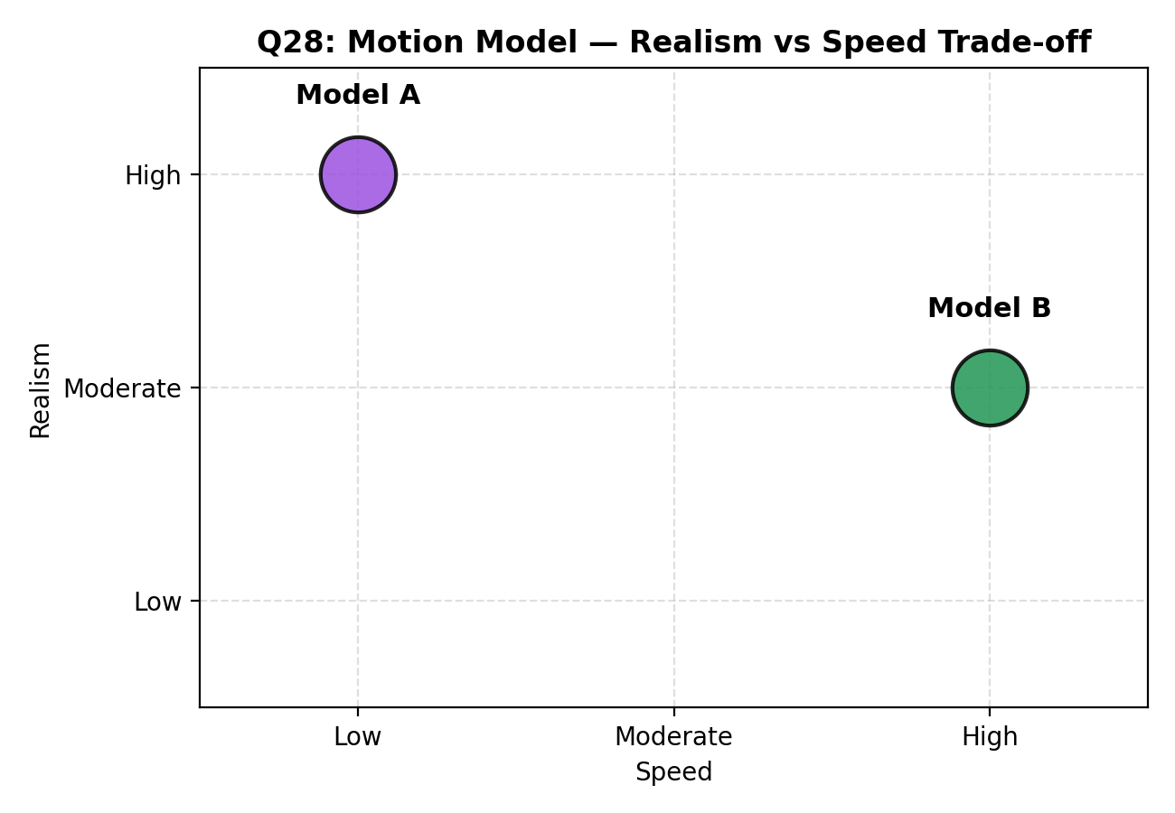

Understanding of Data
Model A produces highly realistic motion but processes it slowly, while Model B produces moderately realistic motion but runs at high speed — a direct trade-off between visual fidelity and computational efficiency.

Analysis
- Model A likely uses physics-based or high-order motion equations that better capture natural, non-linear movement, at the cost of computation.
- Model B likely uses a simplified motion model (e.g., linear or constant-velocity assumptions), which sacrifices some realism for speed.
- The choice depends on whether the application values visual/behavioral accuracy or responsiveness more.
Application of Concepts
In application-critical contexts, the deciding factor is the cost of an error versus the cost of delay. High-realism motion models matter where physical accuracy drives decisions; high-speed models matter where responsiveness or scale is the priority.
Conclusion
Model A is best suited for applications such as animation, simulation, or biomechanical analysis where realism is critical and processing can happen offline. Model B is best suited for real-time applications such as gaming, robotics, or live tracking, where responsiveness outweighs the need for perfect realism.

Question 29: Detection under Occlusion
Method | Accuracy
A | 70%
B | 85%
C | 90%
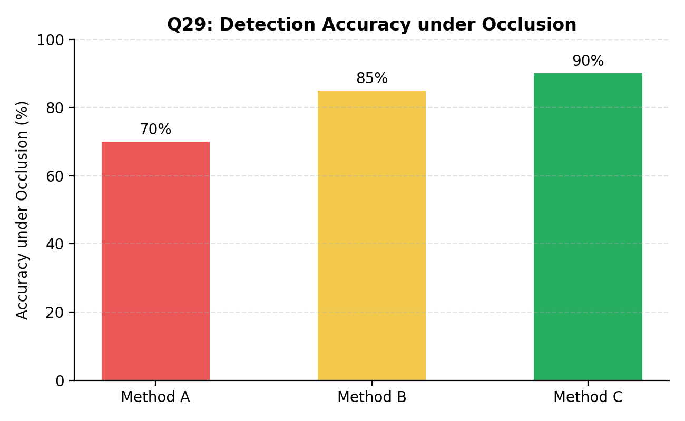

Understanding of Data
Accuracy under occlusion increases progressively from Method A (70%) to Method B (85%) to Method C (90%), indicating a clear ranking in robustness to partially hidden or blocked objects.
Analysis
- Method A likely relies on complete object appearance and struggles when key features are hidden.
- Method B likely incorporates partial-feature matching or contextual cues, improving performance when parts of the object are missing.
- Method C likely uses strong context modeling (e.g., part-based models, attention mechanisms, or temporal continuity in video) to infer occluded regions, giving it the best robustness.

Application of Concepts
Occlusion handling is critical in real-world environments such as crowded scenes, autonomous driving, and surveillance, where objects are frequently and unpredictably blocked by other objects or people.
Conclusion
Method C is the most robust technique under occlusion and is recommended for applications with frequent partial visibility, such as pedestrian detection in traffic or object tracking in crowded scenes. Method A is only advisable in controlled environments where occlusion is rare.

Question 30: System Performance under Constraints
Model | Accuracy | Latency | Cost
A | 88% | 50 ms | Low
B | 92% | 80 ms | Moderate
C | 95% | 120 ms | High

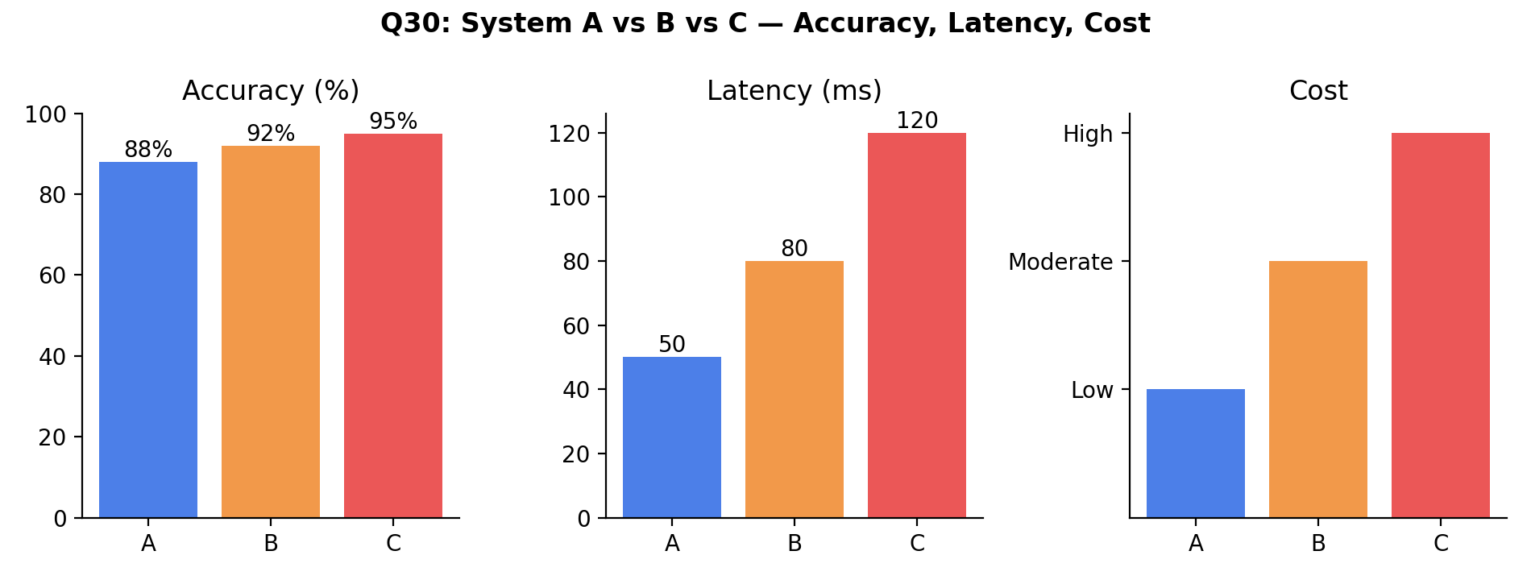

Understanding of Data
As accuracy increases from Model A (88%) to Model C (95%), both latency and cost increase proportionally — latency rises from 50 ms to 120 ms, and cost rises from Low to High. This shows a classic three-way trade-off among accuracy, speed, and cost.
Analysis
- Model A offers the best efficiency (fastest, cheapest) but the lowest accuracy of the three.
- Model C offers the best accuracy but is more than twice as slow as Model A and carries the highest cost.
- Model B offers a balanced middle ground, gaining 4% accuracy over A for a moderate increase in latency and cost.

Application of Concepts
Choosing the 'best' system requires weighing constraints against the deployment context: edge devices and real-time systems with tight budgets favor low latency and cost; high-stakes applications (e.g., medical diagnosis, security-critical detection) can justify higher latency and cost for maximum accuracy.
Conclusion
For resource-constrained or real-time deployments (e.g., mobile or embedded vision systems), Model A is the best choice. For accuracy-critical, less time-sensitive deployments (e.g., medical imaging analysis), Model C is preferable. For most general-purpose production systems, Model B offers the best overall balance of accuracy, latency, and cost, and is the recommended default.

Decision Framework: How to Choose the Right Model
The flowchart below summarizes the general decision process applied across all five questions — matching technique, pipeline, or model to the demands of the target application.
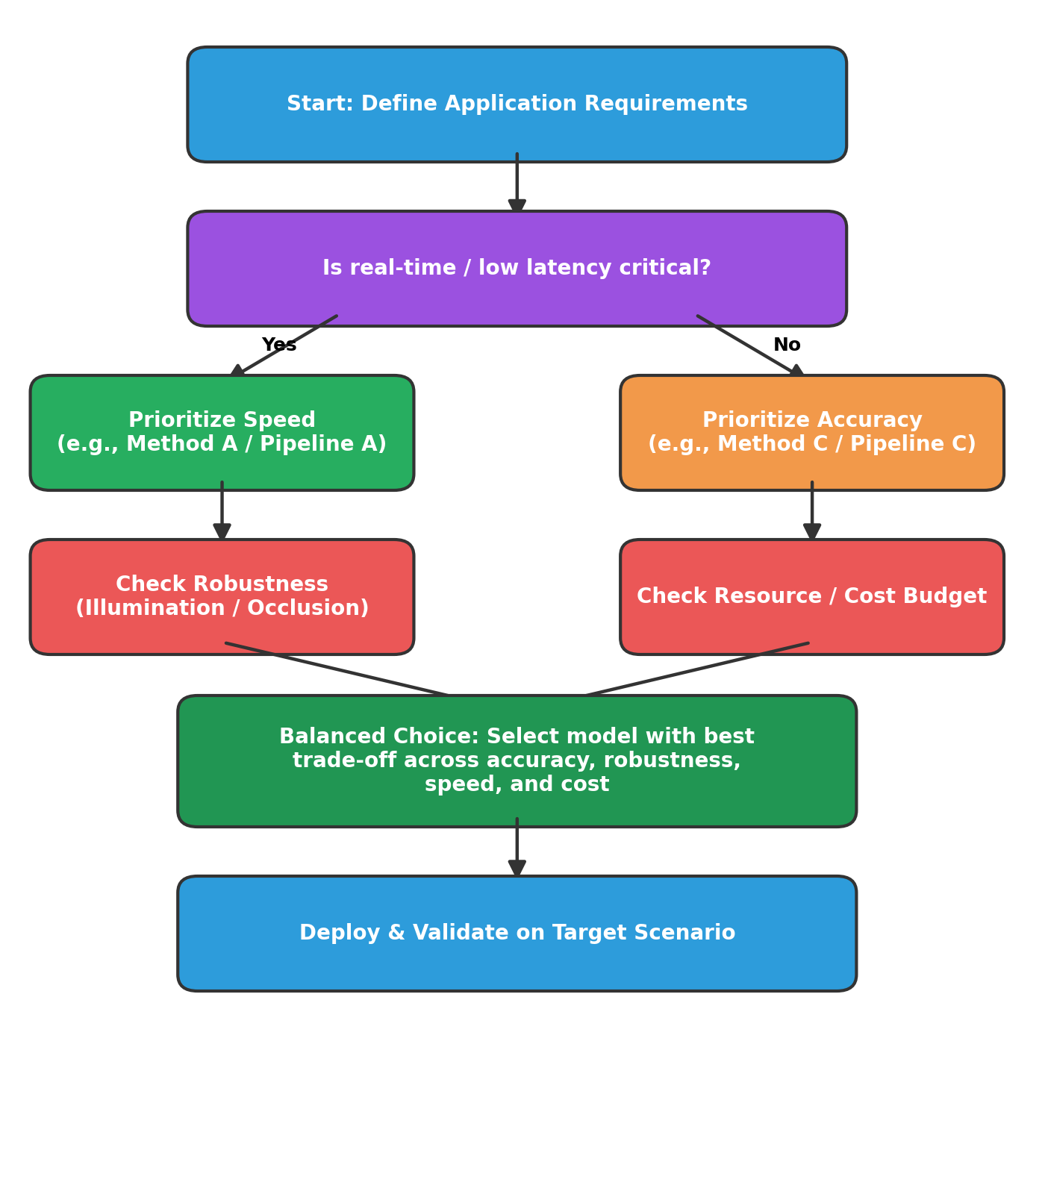

Overall Summary
Across all five comparisons, a consistent pattern emerges: methods optimized for raw accuracy tend to be slower and less robust to real-world variation (illumination, occlusion), while methods optimized for speed and efficiency tend to sacrifice some accuracy or robustness.

